PROGRAM FILE 1

**AIM=** ARITHMETIC OPERATORS

CODE:

a=10

b=20

print("sum is :",a+b)

print("diff is :",a-b)

print("product is :",a*b)

print("quo is :",a/b)

print("quo is :",a//b)

print("rem is :",a%b) #remainder

OUTPUT:

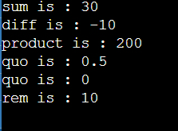

**PROGRAM 2**

**AIM=** RELATIONAL OPERATORS

CODE:

#relational operators

a=10 #assignment

b=20

print("a>b",a>b)

print("a>=",a>=b)

print("a<b",a<b)

print("a<=b",a<=b)

print("a==b",a==b) #comparison

print("a!=b",a!=b)

OUTPUT:

